**Lab 5: Common-Emitter NPN Voltage Amplifier**

EE 3310L

Spring 2023

**Alex Yeoh**

Cauy Gibson

Submitted to TA: C. Hicks Friday 9:00 AM

Date of Experiment: 02/10/23

Date of Submission 02/17/23

1. **Introduction**

The purpose of this lab is to construct and test a simple common-emitter voltage amplifier using a 2N3904 NPN bipolar junction transistor [1]. The DC values of the circuit can be measured separately from any portion with a capacitor between them the transistor due to capacitors acting like open circuits with DC.

1. **Experimental Methodology [1]**

The first step of the experiment is constructing the circuit following figure 1 below, while ensuring that none of the transistors have an hFE less than 100.

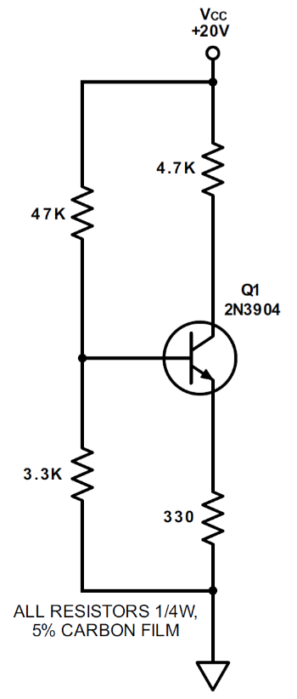

Figure 1: DC portion of a common-emitter NPN voltage amplifier

From the circuit, VB, VE and VC are measured. The circuit is then used to build the circuit seen below in figure 2.

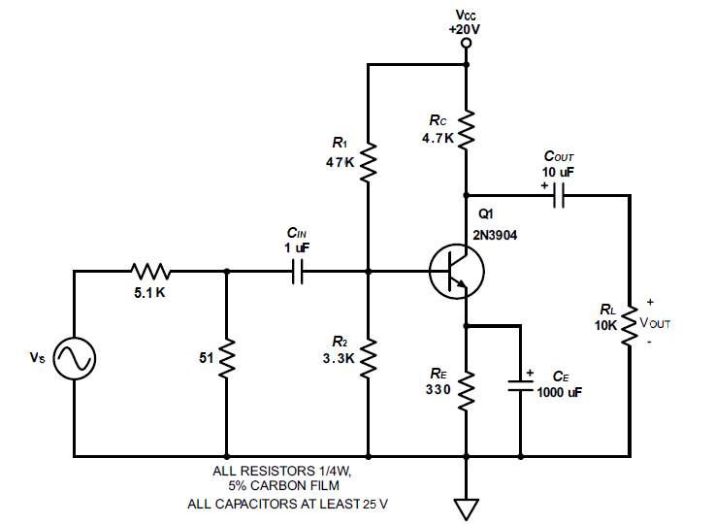

Figure 2: Full common-emitter NPN voltage amplifier

The signal generator is then set to a 1Vp-p and 1kHZ sine wave. The peak-to-peak output voltage is then measured. The frequency is then increased until the output has decreased by 3dB, the resulting frequency is written down as the upper cutoff frequency. The frequency is then decreased until the output has also decreased by 3dB, the resulting frequency is written down as the lower cutoff frequency. The signal generator is then brought back to a frequency of 1kHz, and the peak-to-peak voltage is then increased until the output waveform is visibly clipping. The circuit is then used to build the circuit seen below in figure 3.



Figure 3: Common-emitter NPN voltage amplifier with emitter feedback

The same procedure done to the circuit in figure 2 is repeated on figure 3 excluding the observation about how the resulting wave looks like.

1. **Results and Description**

The measured values of VB, VE and VC for the circuit in figure 1 above are 1.31V, 0.63V and 11.41V respectively.

The wave generated from the circuit in figure 2 above did appear to look like an inverted sine wave.

The measured values for the circuit in figure 2 above can be seen in the table 1 below.

Table 1: Measured values for the common-emitter NPN voltage amplifier

From the values seen above in table 1, the calculated gain from the circuit seen in figure 2 can be seen in equation 1 below.

$A_{V}=\frac{V_{OUT}}{V_{S}}=\frac{1.96}{(0.104/100)}=1885=65.5dB$ (1)

The measured upper and lower cutoff frequencies for the circuit seen in figure 2 above are 2.03MHz and 15Hz respectively.

The peak-to-peak voltage at which the circuit seen in figure 2 above’s waveform appears clipped is 11.9Vp-p.

The measured values for the circuit in figure 3 above can be seen in the table 2 below.

Table 1: Measured values for the common-emitter NPN voltage amplifier with emitter feedback

From the values seen above in table 2, the calculated gain from the circuit seen in figure 3 can be seen in equation 2 below.

$A_{V}=\frac{V_{OUT}}{V_{S}}=\frac{10.2}{(0.104/100)}=9807.7=80dB$ (2)

The measured upper and lower cutoff frequencies for the circuit seen in figure 3 above are 3.4MHz and 80Hz respectively.

The peak-to-peak voltage at which the circuit seen in figure 3 above’s waveform appears clipped is 1.5Vp-p.

1. **Discussion**

The analytically determined DC operating point, gain, and both upper and lower cutoff frequencies can be seen below in figure A1 in appendix a.

The Multisim simulated DC operating point for a common-emitter amplifier can be seen below in figure 4.

Figure 4: Simulated DC operating point from Multisim for a common-emitter amplifier

The Multisim simulated gain and both upper and lower cutoff frequencies for a common-emitter amplifier can be seen below in figure 5.

Figure 5: Simulated gain from Multisim for a common-emitter amplifier with upper and lower cutoff frequencies displayed

The simulated DC operating point was vastly different from both the analytically calculated and experimental values. The simulated gain was roughly in between the calculated and experimental gains, with it being approximately 7dB above the calculated gain and 5dB below the experimental gain. The calculated and simulated upper and lower cutoff frequencies were relatively similar, but the experimental lower cutoff frequency was much lower while its upper cutoff frequency was much higher.

1. **Summary and Conclusions**

The most of lab itself is simple and straightforward to complete due to the instructions given. There was a minor issue with us using a 10x probe while the oscilloscope was set to a 1x attenuation. This was by no means a fault with the lab instructions and simply a mistake on our end for not checking our attenuation setting. Fortunately, this was easily resolved by moving some decimal points in our measured values.

**Reference**

[1] Tritschler, Joe. "Common-Emitter NPN Voltage Amplifier." N.p., n.d. Web. 10 Feb 2023.

**Appendix A**

Analytical Calculations for Lab 5

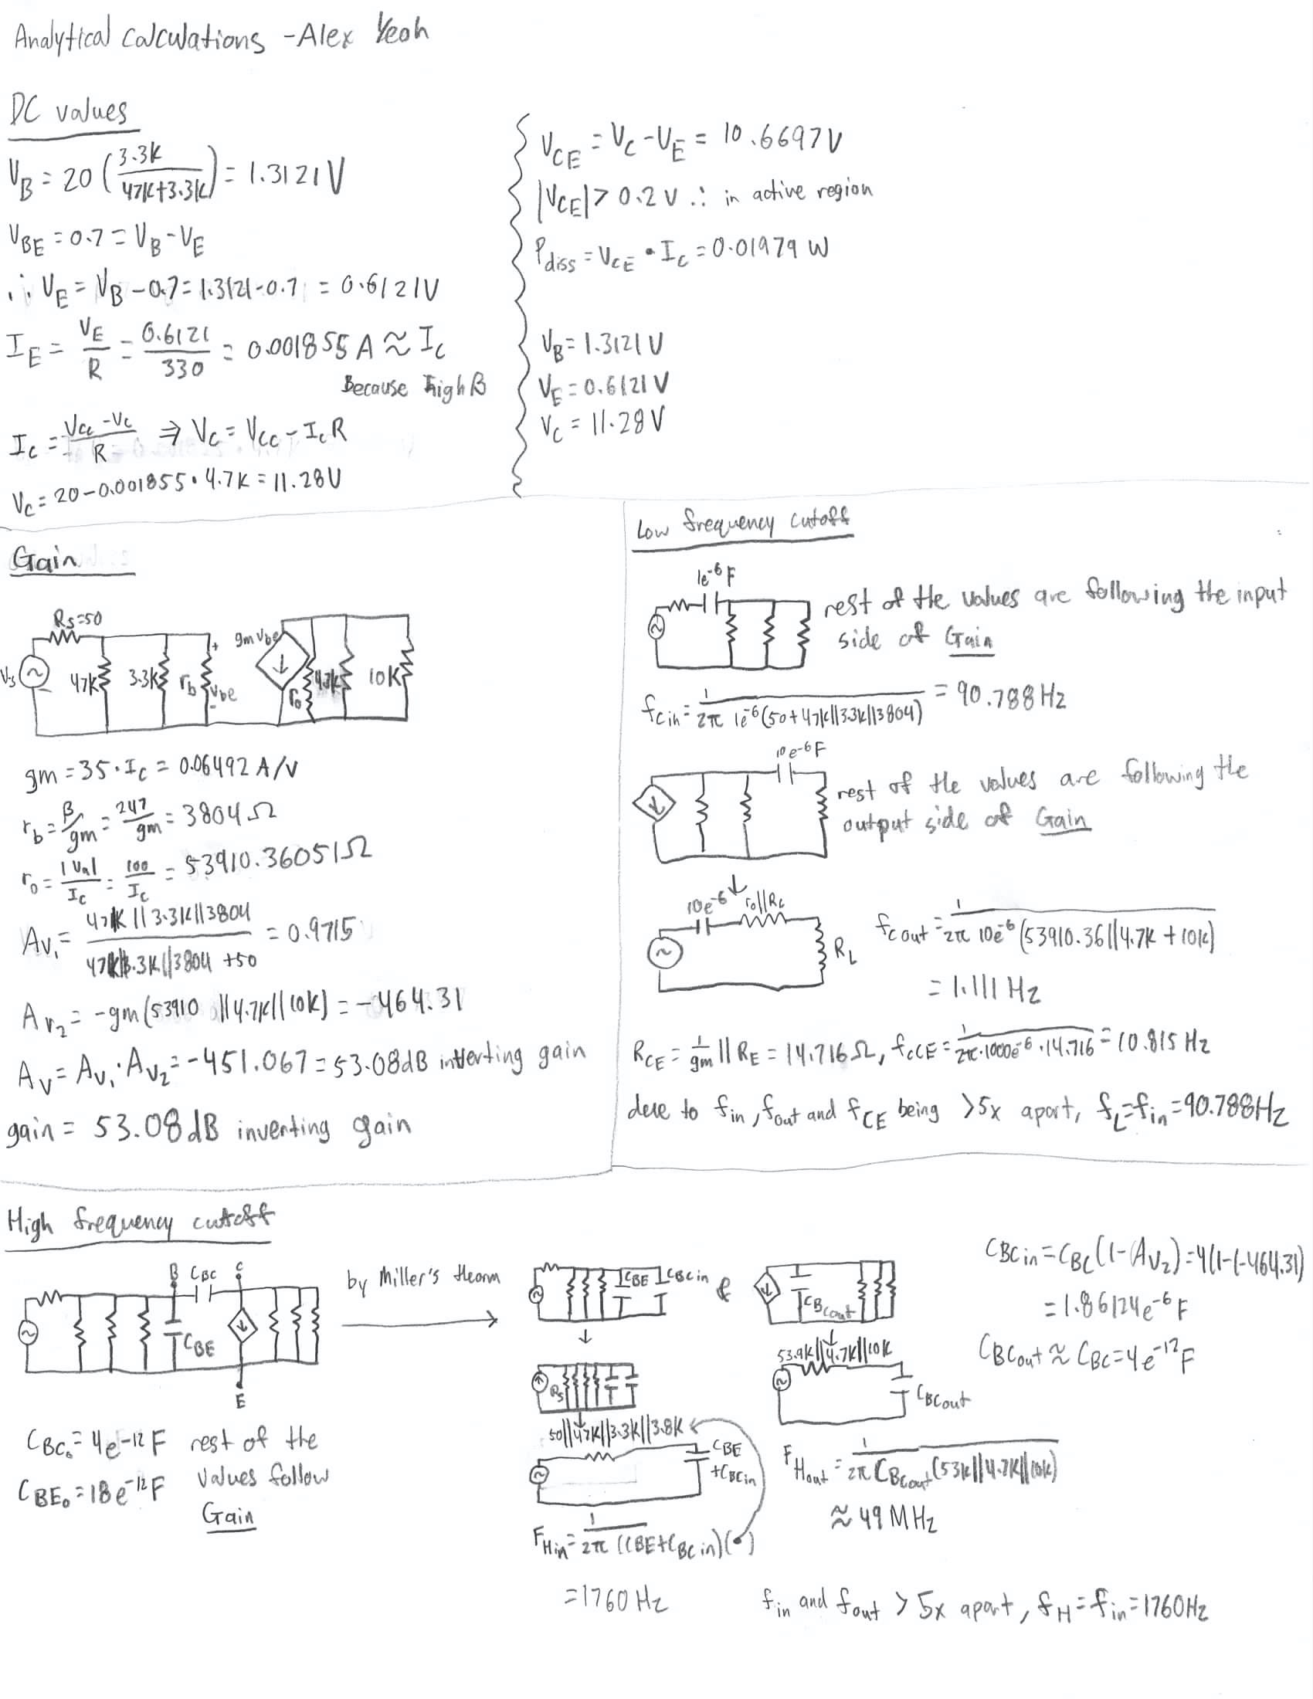

Figure A1: Analytical calculations for the common-emitter amplifier.